FIREBASE INSTALLATION:

1. CREATE FLUTTER PROJECT
2. CREATE FIREBASE PROJECT WITH (Flutter)

**Install NodeJs following code..**

1.sudo apt-get -f install

2.sudo apt-get install nodejs

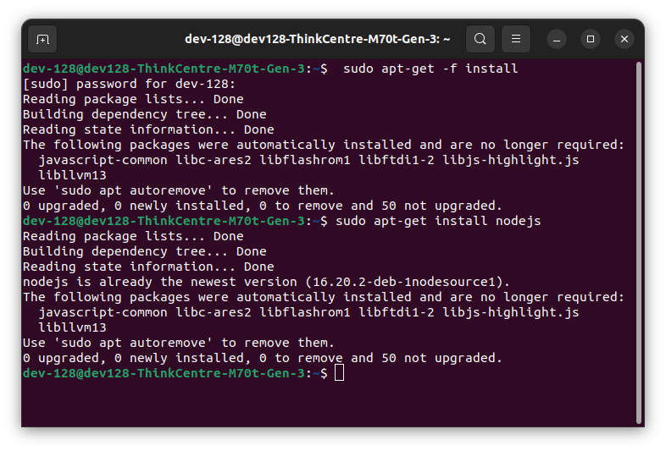

**Check your NodeJs version:**

**Install nvm:**

1. **curl -o- https://raw.githubusercontent.com/nvm-sh/nvm/v0.37.2/install.sh | bash**

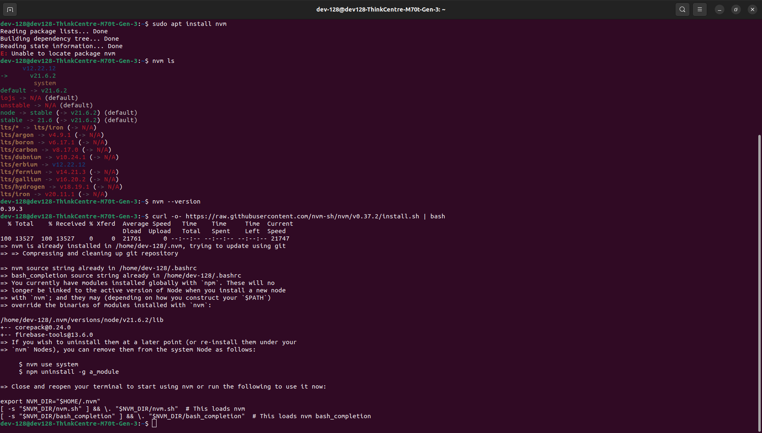

1. **nvm ls-remote(select the recent version for firebase v^18.0.0)**
2. **nvm install v21.6.1**

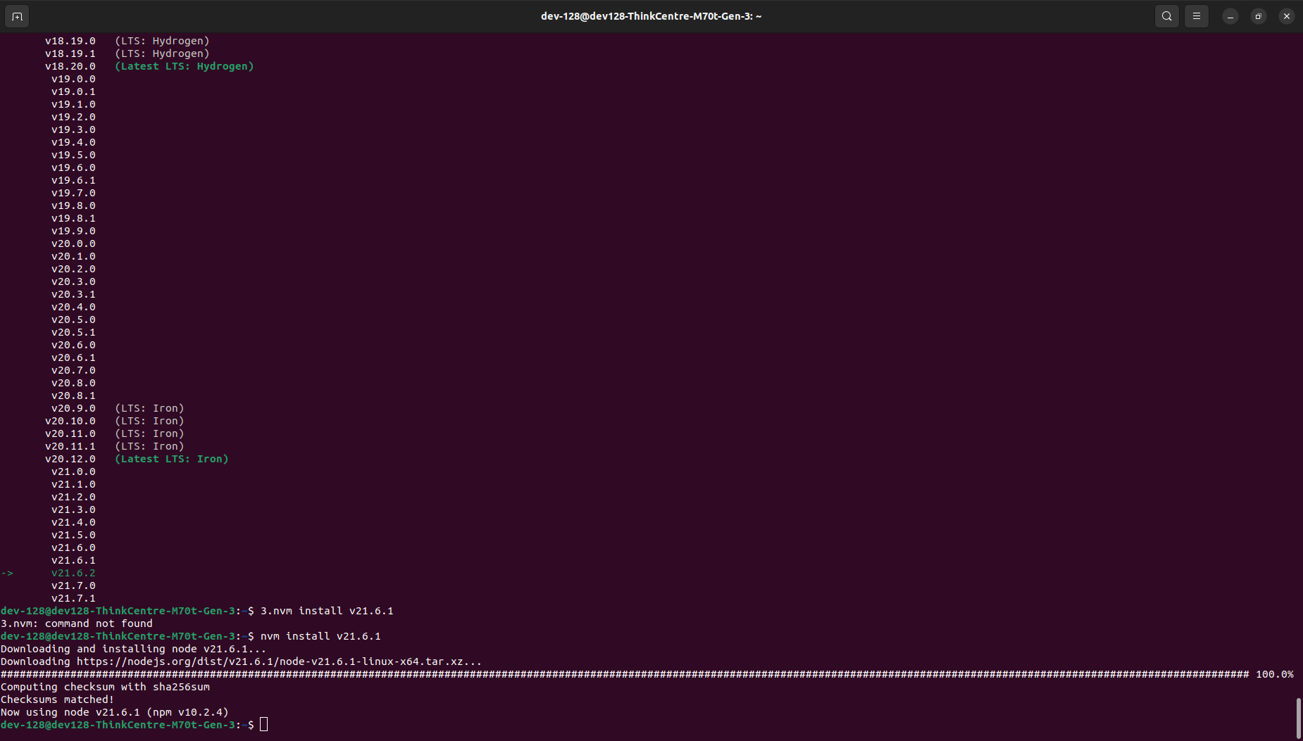

**CREATE FIREBASE PROJECT IN FIREBASE CONSOLE....(FLUTTER)**

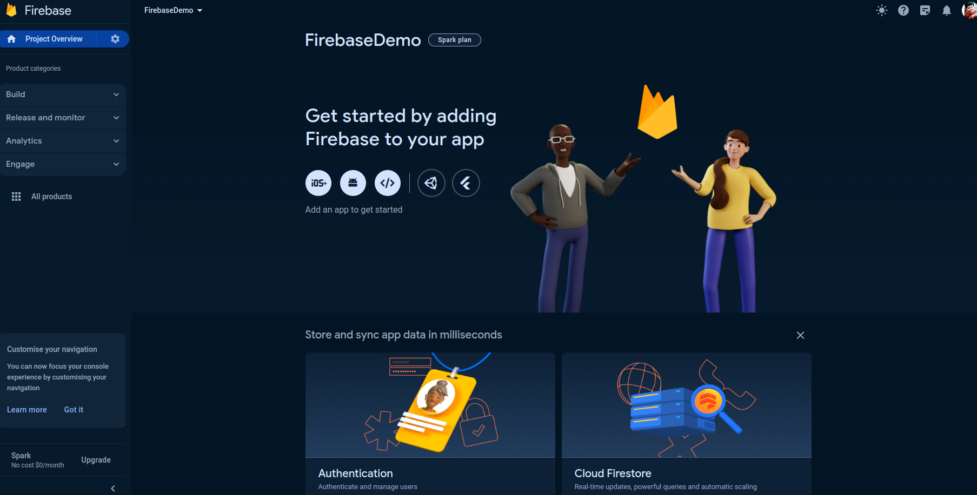

1. npm install -g firebase-tools

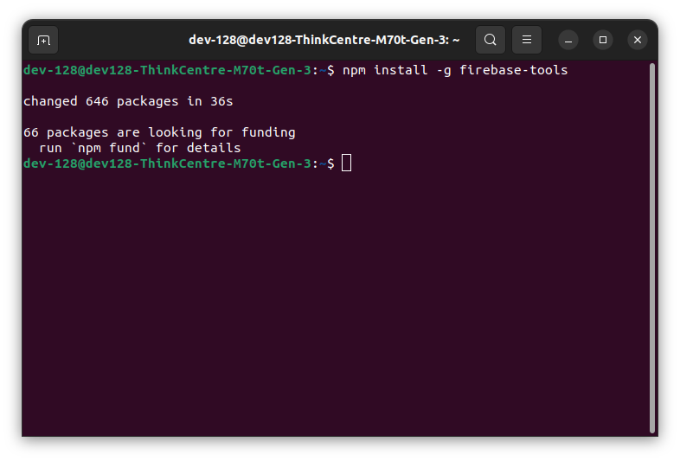

**CREATE FLUTTER PROJECT(firebaseDemo):**

1. firebase login

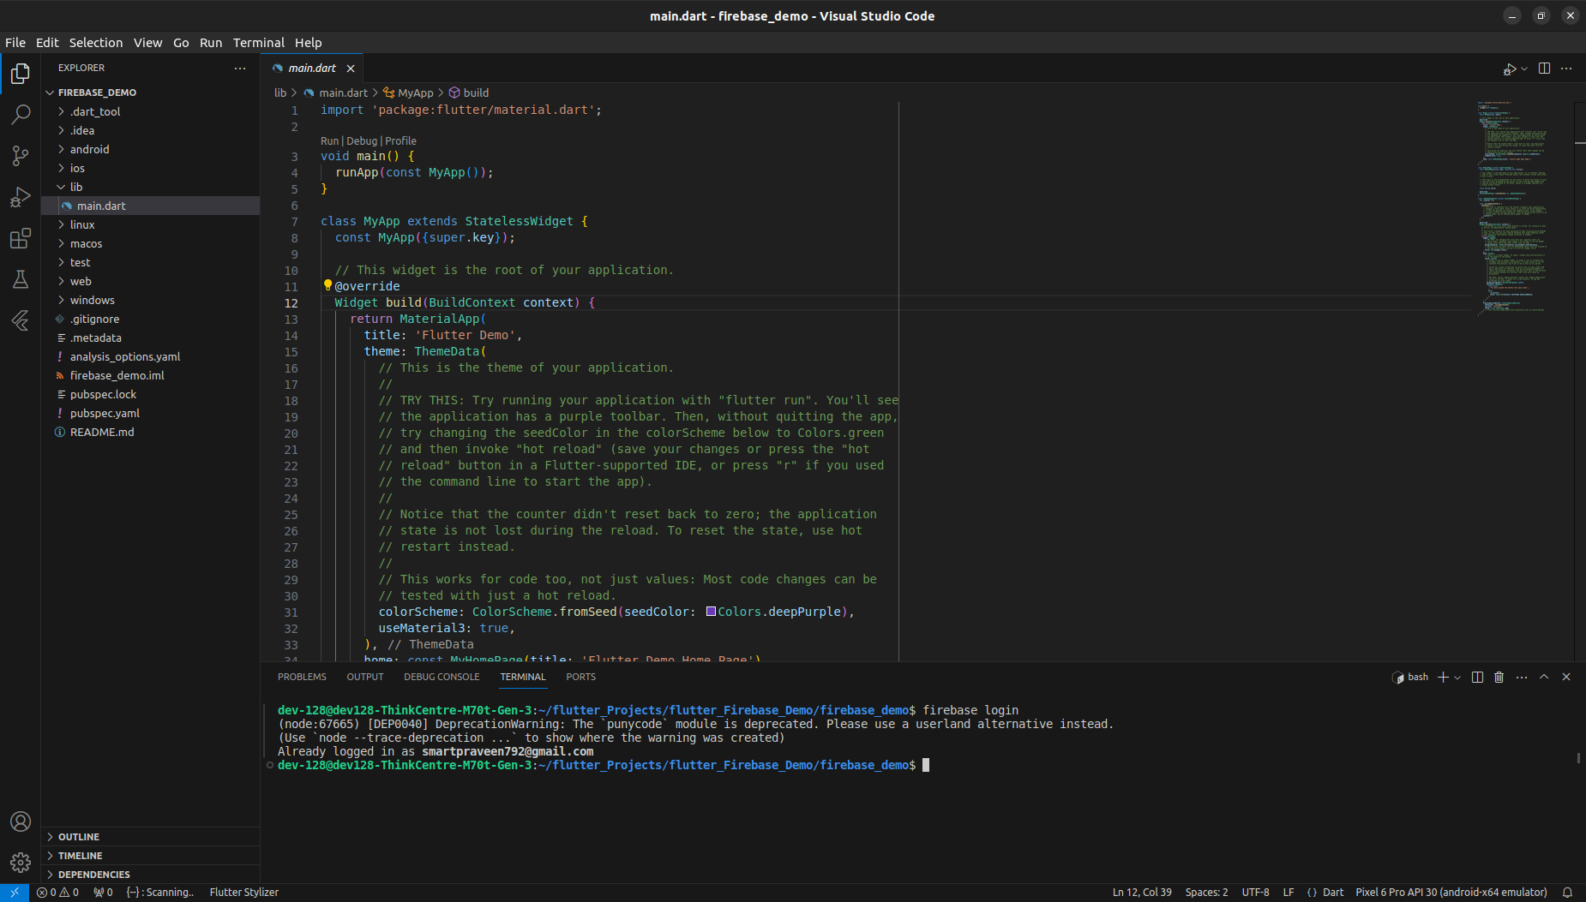

1. dart pub global activate flutterfire_cli

2.1 export PATH="$PATH":"$HOME/.pub-cache/bin"

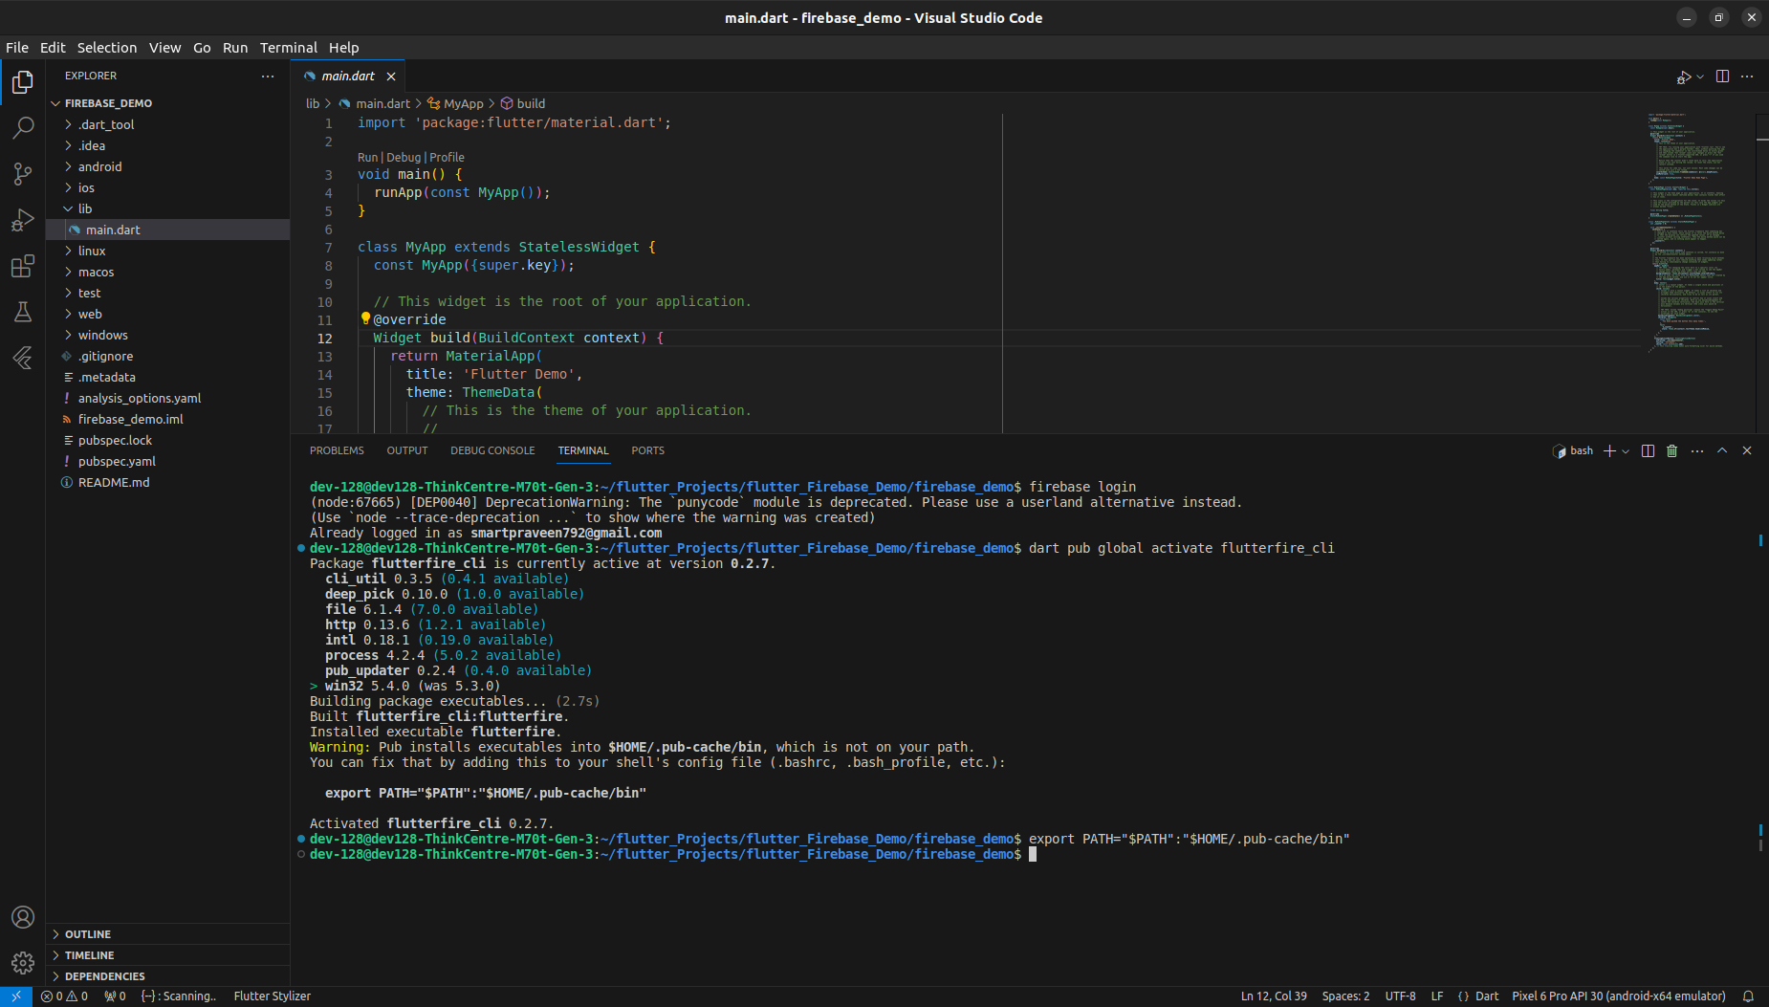

1. flutterfire configure

